Assignment for **Oracle E- Business Procurement/Purchasing**

**Nathaniel Fischer**

Date:22nd Nov-2024

[Provide screenshots of each step (which performed in a live environment).  
As evidence all the activity screens shot needs to be attached].

1. Check one of the existing Supplier, check this Supplier eligible for the Followings or not.

**RFQ , Purchasing, Payment**

Path

Login to Oracle EBS > Switch to Purchasing, Vision Operations (USA) Responsibility 

Supply Base > Suppliers

This will open an HTML page

* Click the “Update” button  beside the supplier of interest
  + A screenshot of a computer

    Description automatically generated
* Select “Address Book” from the left hand menu
  + A screenshot of a computer screen

    Description automatically generated
* Click the pencil icon  in the “Update” column
  + A screenshot of a computer

    Description automatically generated
* You will see the supplier eligibility information listed under the “Contact Details and Purpose” section
  + A screenshot of a contact page

    Description automatically generated

This supplier’s address is valid as both a purchasing site and a payment site, but not a request for quotation site.

2. For The same above Supplier checks the Bank details & Payment Method.

After clicking the “Update” button  and bringing up the supplier information as per the instructions above:

Banking Details

* Click “Banking Details” from the left hand menu
  + A white background with black text

    Description automatically generated

The supplier’s banking information will be displayed.

This supplier has no banking information in the system.

Payment Details

* Click “Payment Details” in the left hand menu
  + A screenshot of a phone

    Description automatically generated

The supplier’s payment details will be displayed.

3. Query one existing Requisition & check what are all information has been captured/update for the respective Requisition.

Path

Login to Oracle EBS > Switch to Purchasing, Vision Operations (USA) Responsibility 

Requisitions > Requisitions

* Press CTRL + F11 to query all requisitions
* Use the up and down arrow keys to scroll through the requisitions
* Header and Line information
  + A screenshot of a computer

    Description automatically generated
* Source Details
  + A screenshot of a computer screen

    Description automatically generated
* Details
  + A screenshot of a computer

    Description automatically generated
* Currency
  + A screenshot of a computer

    Description automatically generated

4. Query one existing PO & check what are all information has been captured/update for the respective PO.

Path

Login to Oracle EBS > Switch to Purchasing, Vision Operations (USA) Responsibility 

Purchase Orders > Purchase Orders

* Press CTRL + F11 to query all purchase orders
* Header and Line information
  + A screenshot of a computer

    Description automatically generated
* Price Reference information
  + A screenshot of a computer

    Description automatically generated
* Reference Document information
  + A screenshot of a document

    Description automatically generated
* More information
  + A screenshot of a computer

    Description automatically generated
* This is a standard purchase order so there is no Agreement information
* Temporary Labor information
  + A screenshot of a computer

    Description automatically generated

5.Explain the key modules of Oracle EBS Procurement Suite.

* Requisitions
  + This module is what allows internal entities to request items
  + Requisitions must be approved before a purchase order for them can be created
  + Requisitions provide justification for purchase orders
  + Requisitions are not required to create a purchase order
* Purchase Orders
  + Purchase orders are used to officially request items from suppliers
  + Purchase orders must be approved before they are finalized
  + The purchase order creator should not also be the approver
* Supply Base Management
  + The supply base management module is used for managing supplier information and supplier quotations
  + Supplier quotations are information the supplier provides regarding the pricing and service information for their offerings
  + Companies will normally send a request for quotation to businesses they are interested in purchasing from
  + Once a favorable quotation has been identified, the supplier will be short-listed and added to the purchasing and payment sites
* Buyer’s Work Center
  + The Buyer’s Work Center is an HTML offering that combines many of the features of the other modules into a single web interface
* Receiving
  + The receiving module is what is used to manage the receipt of goods
  + This module allows you to track items, generate receipts, and manage returns

6. What is the **PROCUREMENT/PURCHASING** key Configuration?  
Each of the setup component what are all Information in captured while configuring need to demonstrate.

**Before the Procurement module can be set up, the master data for items and suppliers must be loaded into the system.**

Path

Login to Oracle EBS > Switch to Purchasing, Vision Operations (USA) Responsibility 

Setup > Organizations > Purchasing Options

Receiving Options

Financial Options

These three option setups must be completed before the purchasing module will function.

Purchasing Options

The options here allow you to control how Purchase Orders are created and approved.

While all of the setup options are important, of special note are the matching options.

There are three types of matching options you can choose from, based on business need:

1. 2 Way: Matches on Purchase Order and Supplier Invoice
2. 3 Way: Matches on Purchase Order, Supplier Invoice, and Receipt
3. 4 Way: Matches on Purchase Order, Supplier Invoice, Receipt, and Inspection

Receiving Options

This is the only setup that must be completed on the Inventory Organization level.

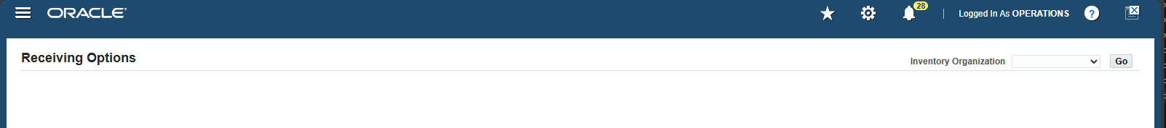

Choose the Inventory Organization you are configuring the options for from the drop down menu and click “Go”

The options here allow you to setup how items should be received.

This includes setting tolerances on order receipt time and order content variation.

Financial Options

These options allow you to control the financial aspects of procurement.

If you do not keep the account information here up-to-date, you will encounter issues with your system processes.

* Supplier – Purchasing
  + A screenshot of a computer

    Description automatically generated
  + These options allow you to select default values that will be used when setting up a new supplier in the system
* Encumbrance
  + A screenshot of a computer screen

    Description automatically generated
  + These options require the use of the Payables, Purchasing, and General Ledger modules
  + These options allow you to enable encumbrance accounting methods for the Purchasing and Payables modules
* Tax
  + A screenshot of a computer

    Description automatically generated
  + This section allows you to specify the tax information for your organization
* Human Resources
  + A screenshot of a computer

    Description automatically generated
  + This section will allow you to set defaults when entering employee information into the “Enter Person” window

7. Navigate Provide screenshots or descriptions of the following:

* The requisition.
* Purchase Order.
* Receipt for PO.

Path

Login to Oracle EBS > Switch to Purchasing, Vision Operations (USA) Responsibility 

Requisition

Requisitions > Requisitions

The requisition is an internal request for specific item(s)

Purchase Order

Purchase Orders > Purchase Orders

Purchase orders are official requests to a supplier for specific items.

Receipt

Receiving > Receipts > [Select Organization]

Receipts show the physical receipt of goods.

8 - 11

Your company requires the following items for a project:

* 5 Desktop Computers
* 10 Office Chairs

You are tasked to procure these items using Oracle Procurement.

Steps to Complete:

9. **Create a Supplier:**

* If the supplier doesn't exist, create a new supplier record, including address, contact information, and payment terms.

10. **Create a Requisition:**

11. **Create a New Purchase Order**: Standard with currency type as USD

Enter **Order Information**:

* **Supplier**: Select the supplier from the list of available suppliers.
* **Order Type**: Choose the appropriate order type (for example, **Standard**).

(9) Create a Supplier

Path

Login to Oracle EBS > Switch to Purchasing, Vision Operations (USA) Responsibility 

Supply Base > Suppliers

* Click “Create Supplier”
  + A screenshot of a computer

    Description automatically generated
* Enter the Supplier information
  + A screenshot of a computer

    Description automatically generated
* Click “Appy”
* Select “Address Book” from the menu on the left
  + A yellow line with black text

    Description automatically generated
* Click “Create”
  + A screenshot of a computer

    Description automatically generated
* Enter the Supplier address and site information
  + A screenshot of a computer

    Description automatically generated
* Confirm and Apply the address creation selections
  + A yellow rectangle with black text

    Description automatically generated
* Select “Contract Directory” from the menu on the left
  + A screenshot of a computer

    Description automatically generated
* Click “Create”
  + A screenshot of a computer

    Description automatically generated
* Enter the supplier contact details
  + A screenshot of a computer

    Description automatically generated
* Click “Apply”
  + A screenshot of a computer

    Description automatically generated
* Select “Payment Details” from the menu on the left
  + A screenshot of a computer screen

    Description automatically generated
* Enter the payment information for the supplier
  + A screenshot of a computer

    Description automatically generated

* Click “Save”
  + A yellow rectangle with black text

    Description automatically generated

The supplier is now set up and ready to use.

(10) Create a Requisition

Path

Login to Oracle EBS > Switch to Purchasing, Vision Operations (USA) Responsibility 

Requisitions > Requisitions

* Enter the requisition information
  + A screenshot of a computer

    Description automatically generated
* Click “Save” 
* Click “Approve”  to approve the requisition
* Click “Ok”
  + A screenshot of a computer screen

    Description automatically generated

The requisition has now been created and approved.

(11) Create a Purchase Order

Path

Login to Oracle EBS > Switch to Purchasing, Vision Operations (USA) Responsibility 

Purchase Orders > Purchase Orders

* Enter the purchase order information
  + A screenshot of a computer

    Description automatically generated
* Click “Save” 

The purchase order has now been created and is ready for approval.

12. Create a Quotation for any of the existing supplier.

Path

Login to Oracle EBS > Switch to Purchasing, Vision Operations (USA) Responsibility 

RFQ’s and Quotations > Quotations

* Enter the supplier and quotation information
  + 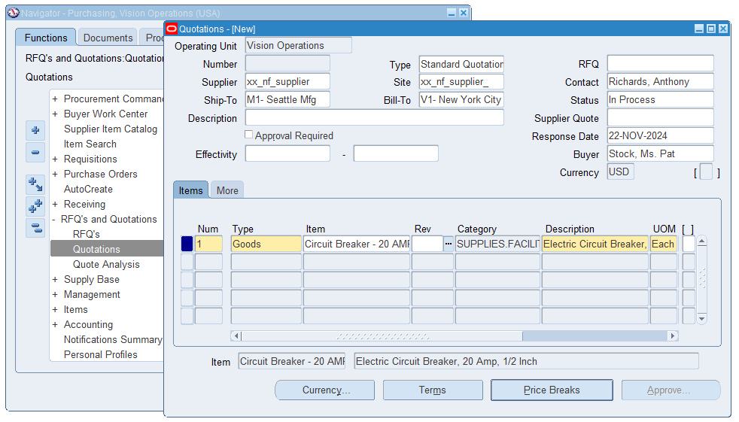
* Click “Save” 

13. Verify all accounts which are updated for financial options.

Path

Login to Oracle EBS > Switch to Purchasing, Vision Operations (USA) Responsibility 

Setup > Organizations > Financial Options

These are all of the accounts that are associated with the Financial Options